PrinterSplitter.exe – Walkthrough and Troubleshooting
Rev. 11/18/2024
Creating Printer Installers
This walkthrough assumes the script is executed from a removable USB drive, but it can be launched from any location.
- We created a folder named PrinterExport on the root of the USB drive, which contains the PrinterSplitter.exe file.
- After inserting the USB drive into a workstation or server, launching the .exe for the first time will display a screen like this:
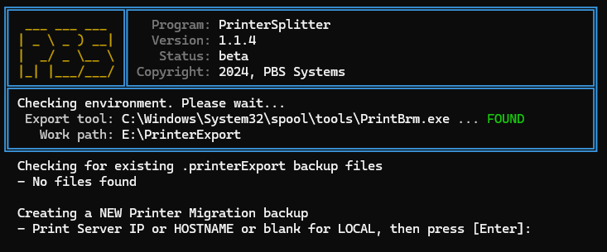
Backup Instructions
- If connected directly to the server, pressing Enter will create a backup using the PrintBrm.exe tool supplied by Windows.
- If connected to a workstation, type the HOSTNAME or IP address of the server where the printers are installed to back up that print server.

If creating a local backup, press Enter.
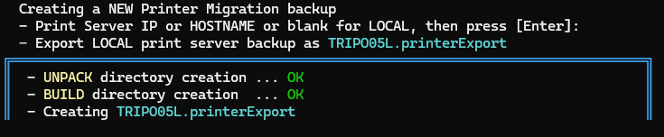
- Depending on the number of printers, available resources, and network connection, the backup process may take a while. Please allow it to complete.
- Once finished, the number of printers to process will be displayed, and the script will begin creating individual installers.
  - Excluded printers (e.g., OneNote and CutePDF) will be automatically skipped.
  - All other printers will be parsed and isolated into individual installers.
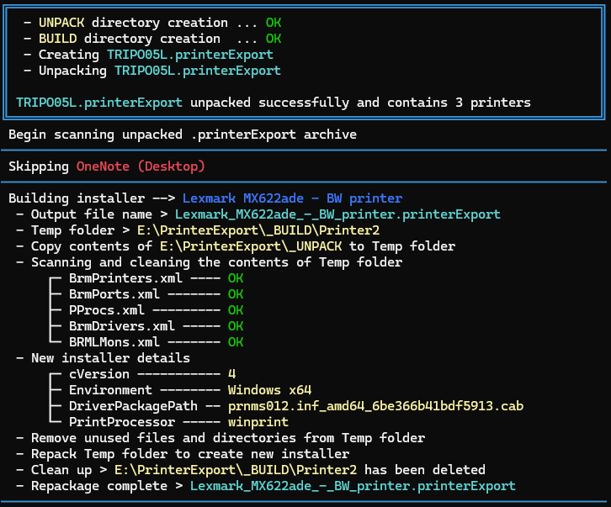

Once the process is complete, a message will indicate that the script has finished and specify where the new printer installers are located:

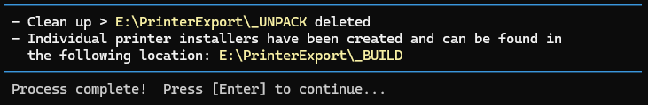

- Checking the PrinterExport directory, you will now see:
  - A _BUILD folder containing the individual printer installers.
  - A PrinterSplitter.log file.
  - A master print server export file, named after the machine itself or the HOSTNAME/IP address entered when prompted.
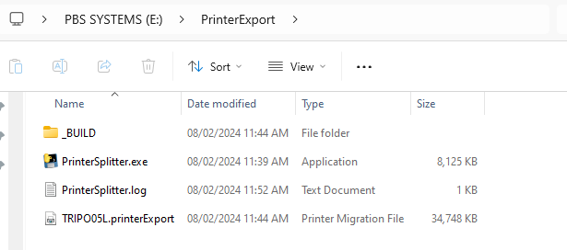

_BUILD Directory
- The _BUILD directory contains the individual printer installers. Each installer replicates the exact printer name, settings, properties, and preferences on the target machine.
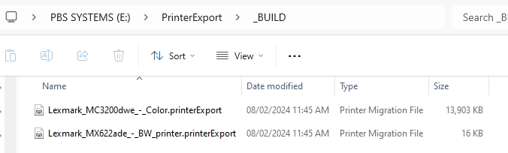
Installing the .PrinterExport Files on a Workstation
To install the printer exactly as it was configured on the server, use the PrintBrmUI.exe tool, located in the tools directory alongside PrinterSplitter.exe.
- Right-click PrintBrmUI.exe and select Run as Administrator to ensure profiles and preferences are installed correctly.
- Select Import printer queues and printer drivers from a file and click Next.
- Click Browse on the following screen.

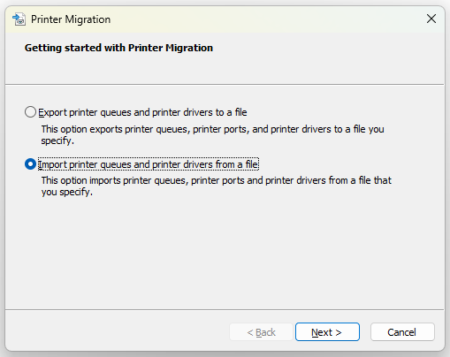
- Go to the _BUILD folder created by PrinterSplitter.exe, select the desired printer, and click Open.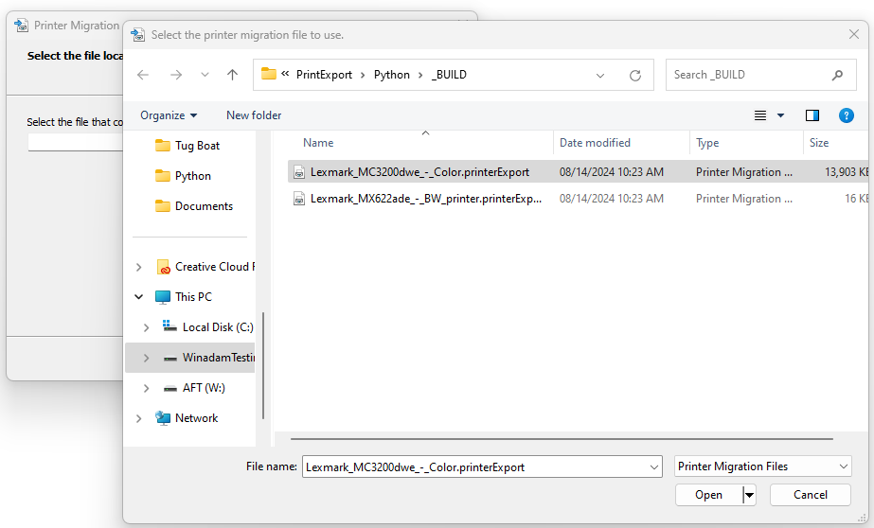

- Review the list of items to be imported and click Next.
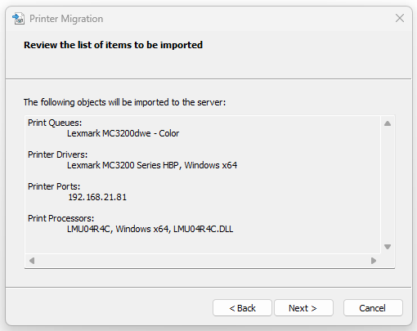
- When prompted to select the print server, ensure the workstation is selected, and click Next.
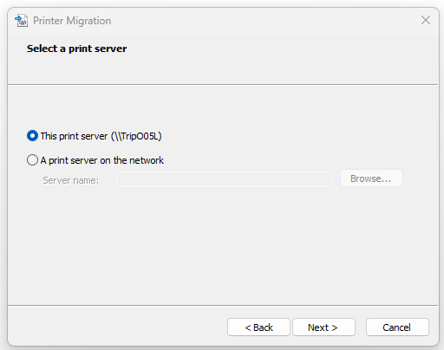
- On the Select Import Options screen:
  - Check Overwrite existing printers.
  - Check Convert LPR Ports to Standard Port Monitors.
  - Click Next.
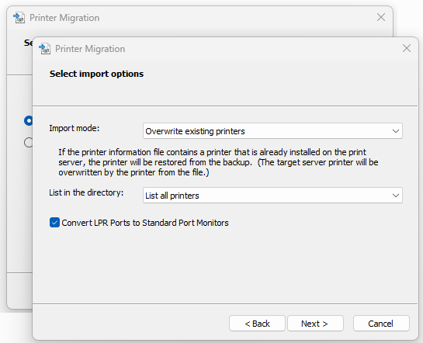
- Once the process is finished, you will see a confirmation message indicating whether any errors occurred.
Repeat these steps for each printer to be installed
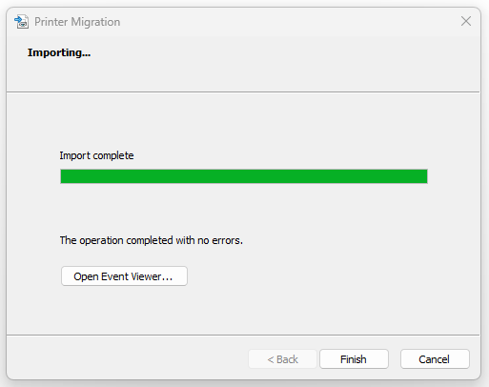
Notes
- When PrinterSplitter.exe runs, any existing _BUILD directory will be deleted and recreated. To avoid overwriting, rename the _BUILD folder after creating the printer installers.
- Once a .PrinterExport file is created, the program will prompt you to use the existing file on subsequent runs. This saves time by skipping the creation of a new file.
- The program will process any existing files in the directory before prompting to create a new file.
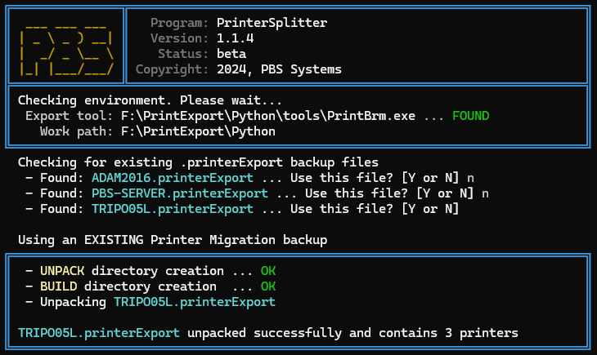

Troubleshooting
- If the script exits with an error stating that PrintBrm.exe is missing, or if there are version-related issues:
  - Run PrinterSplitter.exe from a command prompt using the argument:
PrinterSplitter.exe -TOOLS
  - This will create a local folder with PrintBrm.exe (v10.0.22621.1) and the necessary tools.
- Use PrinterSplitter.exe -HELP to view all available command-line arguments.
- Use PrinterSplitter.exe -NOCLEAN to keep all temporary files for review.

Suggestions
- Consider renaming the _BUILD directory to reflect the file name, so each run generates its own uniquely named folder.

